Artificial Assessment Intelligence – For Educators (AAIE) Report

- Team Information
- Team: Solution Architecture Team in Model Training
- Lead: VAN HIEU NGUYEN
- Member: UMAR KHAYAM
- Product Owner: ARNAVE AHUJA
- Scrum: KHUSHI CHOUBEY

- Create Solution Architecture (Week 1 and Week 3)

Objective: Create Solution Architecture, including data flow diagram for AI-generated content detection and feedback generation, draw the system architecture and add data flow annotations.

Use case:
- AI Detection: Automatically label student writing as AI or human-generated with confidence explanation (show as percentage)
- Feedback Generation: Automatically generate personalized feedback based on rubric and student response (as prompt)

Solution Architecture:
- AI Detection:
- Input: Student text
- Modules: Pre-processing → Embedding → Classifier → Confidence/ Explanation
- Output: AI/Human label + explanation
- Feedback Generation:
- Input: Student response + rubric
- Modules: Text Cleaning → Feature Extraction → Rubric Matcher / student response → LLM Generator
- Output: Natural language feedback + rubric tags

Instruction:
- Create data/model flow diagram for AI-generated content detection:
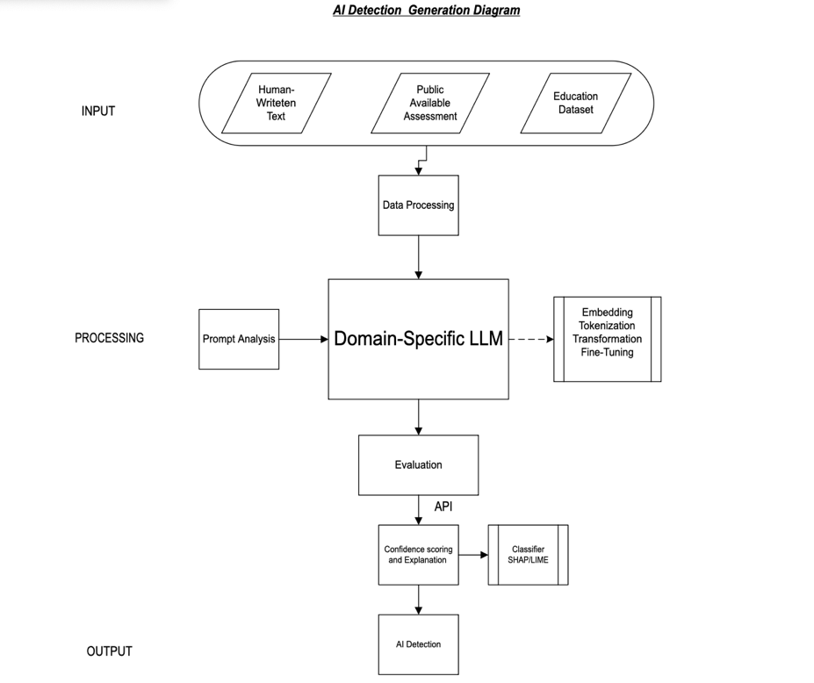

- Data Flow:
- Input: string/JSON → Output: JSON
- Embeddings: vector shape (768,)
- AI Detection: AI or Human
- Example:
- Input: prompt engineering
- Expected Output:
{
"label": "AI",
"confidence": 0.72,
"explanation": "Unusual phrase repetition similar to GPT"
}

- Design flow diagram for rubric-aligned feedback generation:

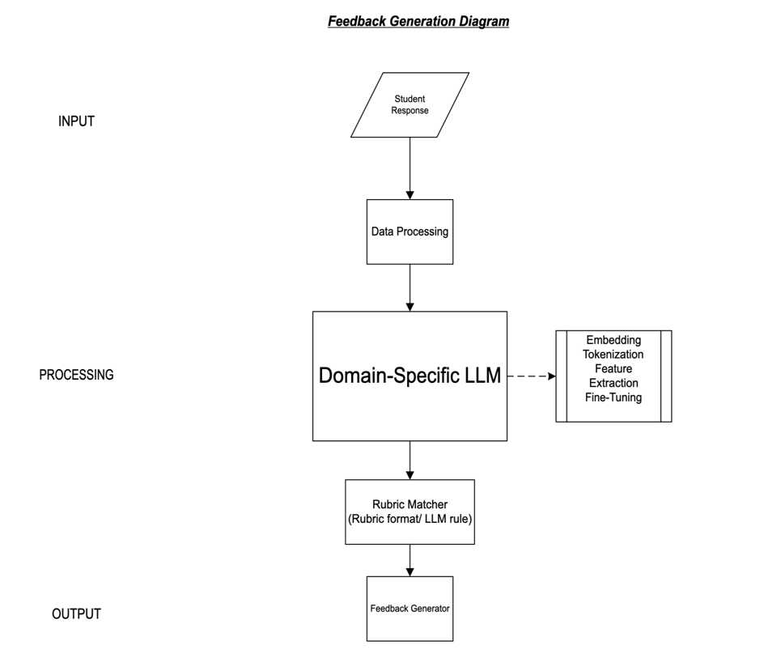

- Data Flow:
- Input: string/JSON → Output: JSON
- Embeddings: vector shape (768,)
- Output: Text, String, or JSON
- Example:
- Input: Student Response
- Expected Output:
{
"feedback": "Here is feedback from your tutor or unit chair."
}

- Draw system-level architecture (block diagram): UMAR KHAYAM

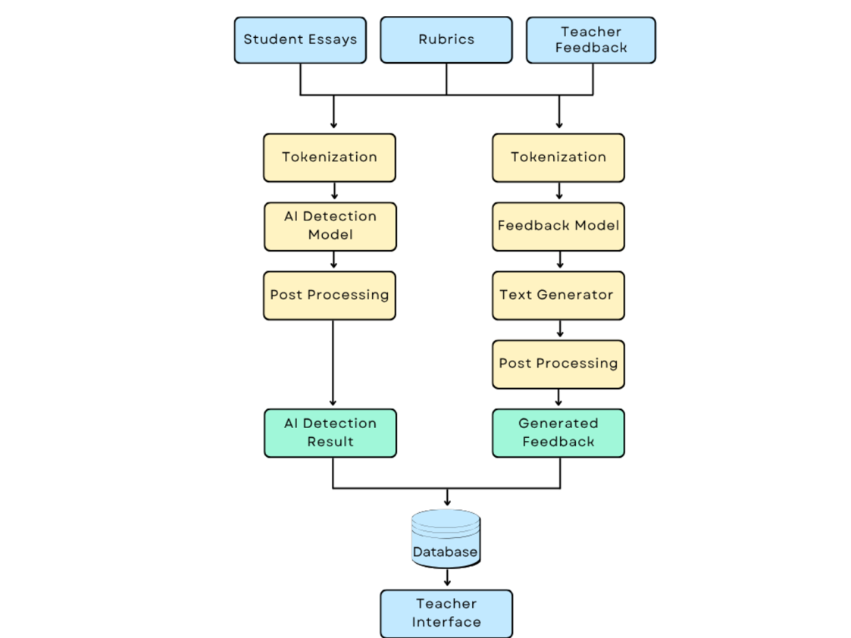

- In Database, it will contain:
- Vector DB: Embeddings
- SQL/NoSQL: Rubrics,
- Logs- S3/GCS: Model Checkpoints

Module Descriptions:

- Pre-processing: clean and normalize input text. Using: NLTK, spacy.
- Tokenizer: tokenize for embedding/model input . Using: BPE, SentencePiece.
- Embedding: encode text to vector. UsingBERT, SentenceTransformer.
- Classifier: classify AI vs Human. Using: MLP, logistic regression.
- Explanation: string explanation. Using: SHAP, LIME.
- Feature Extractor: extract NLP features. Using: custom NLP.
- Rubric Matcher: align response to rubric. Using: Rule-based / LLM prompts.
- Feedback Generator: produce rubric-aligned feedback. Using: GPT prompt, LLM.
- API Gateway: route frontend/backend requests . Using: FastAPI, Flask.

